“MERGING WITH COMMIT-ID”

Created a branch named ‘devops-03’

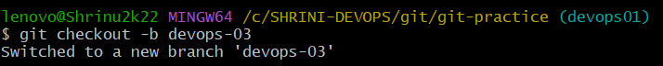

Created a file named “eee11”



Then checking the status by “git status” command

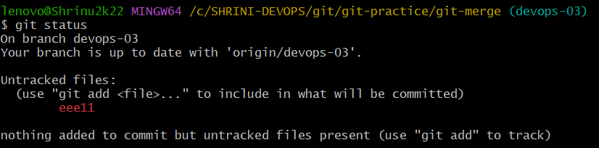

After that I am added and commit the file to the branch “devops-03” with the message of ‘devops-concept’

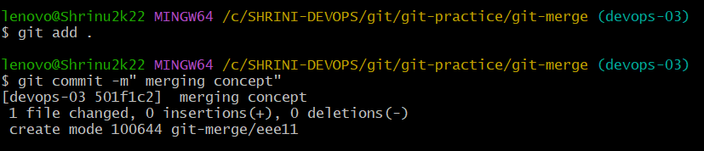

And then I checked the log for commit –id

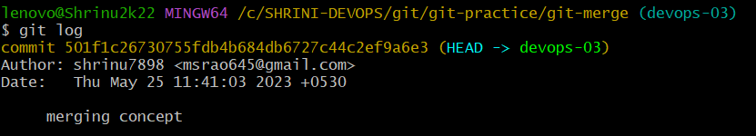

Then I switch the branch to “master”

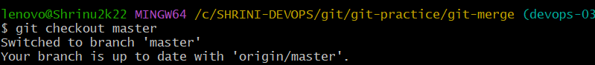

And Now, I want to add that commit id with the message of “merging concept” with the command “git merge 501f”

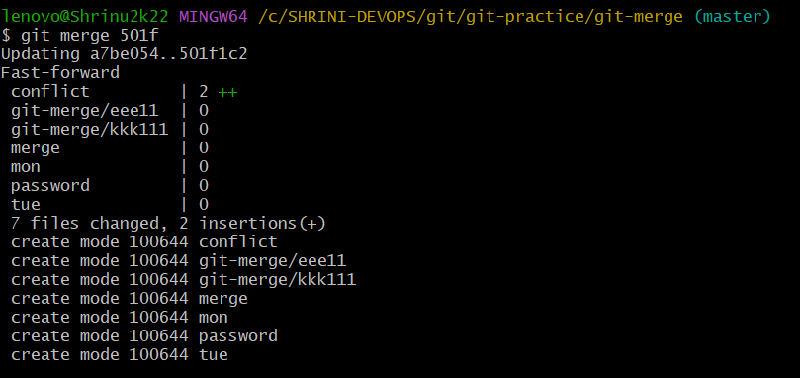

Lastly I checked the files it in the master branch or not by “ll” command

